Habitat Quantity Drives Community Assembly and Feedbacks to Coral Condition in Reef Systems

Adrian C. Stier¹, Alexander Primo², Joseph S. Curtis^{1,3}, Craig W. Osenberg⁴
¹Department of Ecology, Evolution, and Marine Biology, and Marine Science Institute, University of California Santa Barbara, Santa Barbara, California 93106, USA; E-mail: astier@ucsb.edu , ORCID: 0000-0002-4704-4145
²Odum School of Ecology, University of Georgia, 140 E Green St, Athens, GA 30602; E-mail: primo1357@gmail.com
³Department of Marine Science, University of Otago, PO Box 56, Dunedin, Otago, New Zealand, 9054; Email: joseph.curtis@otago.ac.nz; ORCID: 0000-0003-1567-4385
⁴Odum School of Ecology, University of Georgia, 140 E Green St, Athens, GA 30602; E-mail: osenberg@uga.edu ORCID: 0000-0003-1918-7904

Short Running Title: Dynamic landscapes on coral reefs
Keywords: coral reefs, habitat quantity, landscape ecology, community assembly, biogenic habitat, coral condition, mutualisms, foundation species
Article type: Letter
Number of words in abstract: 150
Number of words in main text: 4934
Number of references: 56
Number of figures, tables, and text boxes: 6 figures
Supplemental Information: 1 figure, 3 tables
Correspondence: Adrian Stier, University of California Santa Barbara, Department of Ecology, Evolution, and Marine Biology, Santa Barbara, CA, 93106 USA. E-mail: astier@ucsb.edu Tel 203 241 8978. No Fax.
Data accessibility statement: All data and code used in this study are publicly available. Raw data files (CAFI community observations, coral growth measurements, and physiological metrics), analysis scripts (R), and documentation are archived on Zenodo (https://doi.org/10.5281/zenodo.18239647) and maintained on GitHub (https://github.com/adrianstier/coral-cafi-density-experiment). All data are released under a Creative Commons Attribution 4.0 International (CC-BY 4.0) license, and code is provided with complete documentation for reproducibility.
Author statement: ACS and CWO conceived of the project. AP and JC conducted the majority of the fieldwork, laboratory, and image analyses. ACS performed the analyses and drafted the figures with input from CWO. ACS wrote the first draft, and ACS and CWO contributed substantially to revisions.

ABSTRACT
Habitat quantity and distribution affects communities, yet less research has explored how those communities feedback to affect the habitat. Reef-building corals create biogenic habitat that hosts diverse assemblages of coral-associated fishes and invertebrates (CAFI), which can help or harm their hosts. The coral landscape can alter recruitment of CAFI to corals, potentially creating feedbacks between the landscape and coral condition that are distinct from traditional spatial effects (e.g., resource-based competition). We manipulated coral number (1, 3, or 6 colonies per plot) and evaluated CAFI communities and coral condition after 17 months. CAFI abundance increased fivefold and species richness doubled from low to high coral-number treatments. Coral condition declined at high coral density as predicted by the decline in per coral CAFI density and shifts in CAFI communities. These results reveal how habitat configuration drives community assembly and feeds back to alter the condition of foundation species, potentially influencing landscape dynamics.

INTRODUCTION
In many systems, landscapes are created by habitat-forming organisms such as trees, corals, kelps, or oysters. The identity, size, and spatial distribution of individuals that comprise these biogenic habitats influence how many organisms recruit to, forage in, or shelter in specific habitat patches, linking traits of foundation species to the density and species composition of constituent animal communities (Hanski 1998; MacArthur & Wilson 1967; Resetarits 2005). Resident organisms do not simply occupy a biogenic habitat; they can also alter its characteristics through their feeding activities (Silliman et al. 2005), nutrient processing (Meyer & Schultz 1985), or interactions with other species (Angelini et al. 2011). As a result, the amount and distribution of habitat patches that form landscapes are themselves a dynamic feature of the ecosystem, simultaneously influencing and responding to the density of occupants. Despite theoretical recognition of habitat-occupant feedbacks (Angelini et al. 2011; Moeller et al. 2023), we lack critical empirical tests that experimentally manipulate habitat and measure: (1) the resulting density of occupants, and (2) the subsequent feedbacks between occupants and habitat traits. Understanding these feedback loops is essential for predicting the dynamics of ecological landscapes, particularly for restoration practitioners who aspire to manipulate foundation species in ways that enhance ecosystem recovery and maximize the health of associated communities.
Two alternative hypotheses represent extremes for how occupants might respond to changes in the amount of habitat. The Field of Dreams Hypothesis (Palmer et al. 1997) proposes that increased habitat availability leads to a proportionate increase in colonists, with no resulting decrease in density at previously existing sites (“if you build it, they will come”). Alternatively, the Propagule Redirection Hypothesis suggests that new habitat redirects colonists away from other suitable sites resulting in a reduction in colonists per unit habitat (Carr & Hixon 1997; Osenberg et al. 2002; Stier & Osenberg 2010). In its most extreme form, Propagule Redirection would result in no total increase in colonists (i.e., it would create a proportionate decrease in numbers per habitat unit). Evidence for these hypotheses is mixed. For instance, Resetarits and Binckley (2009) found a linear increase in beetle colonization with habitat amount, supporting the Field of Dreams hypothesis. In contrast, Stier and Osenberg (2010) showed that isolated corals (low-habitat landscapes) received ~4× more colonizing fishes than equally sized corals surrounded by neighbors, consistent with Propagule Redirection. Subsequent modeling (Hamman et al. 2018) suggested that factors such as occupant longevity, intraspecific competition, and migration frequency can modulate outcomes along the Field of Dreams to Propagule-Redirection spectrum.
Across realistic landscapes with uneven distributions of a biogenic habitat, the Propagule Redirection hypothesis predicts that per-unit occupant density will be highest in areas with less total habitat while the Field of Dreams hypothesis predicts an invariant occupant distribution. Ecological consequences of these divergent distributions of animal communities will depend on the nature of interactions between habitat-forming organisms and resident species. For example, under the Propagule Redirection scenario, a landscape with sparse habitat and therefore high occupant densities will perform well if occupants benefit the habitat (e.g., through nutrient subsidies), but poorly if they impose costs (e.g., via consumption or fouling) (Bissett et al. 2025; Jones et al. 1997). These feedbacks close a loop between habitat dynamics and occupant dynamics, with potential to drive spatial pattern formation and ecosystem trajectories across diverse systems where foundation species structure communities.
In marine systems, biogenic habitats such as seagrass beds, oyster reefs, kelp forests, and coral reefs are in global decline due to anthropogenic stressors including climate change, overfishing, and pollution (Angelini & Silliman 2012; Beck et al. 2011; Byrnes et al. 2011; Day et al. 2007; Graham 2004). These habitats support diverse and abundant communities of associated organisms that can affect habitat condition and long-term recovery after disturbance (Kimbro et al. 2017; Rennick et al. 2022; Renzi & Silliman 2021). Habitat size, spacing, and fragmentation can influence species distributions, but most studies in marine systems have focused on spatial correlations in abundance rather than causal mechanisms (Pittman et al. 2011). Similarly, while it is well known that variation in density of habitat-associated organisms can affect biogenic habitat (e.g., Shaver et al. 2018; Valdez et al. 2020), fewer studies have explicitly linked these effects to reciprocal feedbacks between landscape structure, occupants, and habitat condition.
Coral reefs offer a powerful model system to test mechanisms for assembly of communities associated with biogenic habitats as well as the ecological consequences of host-occupant interactions. Reef-building corals create complex three-dimensional habitats that support diverse assemblages of coral-associated fishes and invertebrates (hereafter CAFI). The interactions between corals and CAFI are well-documented and often strong. Some CAFI benefit corals by defending them from predators or removing sediment and debris (Glynn 1983; McKeon et al. 2012; Stewart et al. 2006; Stier et al. 2010). Others, such as corallivorous gastropods, reduce coral growth and facilitate disease or coral bleaching (Boucher 1986; Fitt 2025; Nicolet et al. 2013; Turner 1997). Beyond these direct effects, protection mutualists such as trapeziid crabs and alpheid shrimps can affect the colonization and establishment of other coral-associated species, thereby shaping broader community trajectories (Counsell & Donahue 2021). Many coral occupants interact strongly through competition and predation (Stier et al. 2013; Stier & Leray 2014), affecting the abundance and diversity of beneficial coral-dwelling organisms in ways that can significantly shape coral fitness and resilience (reviewed in Stier & Osenberg 2024).
Moreover, studies on coral-associated fishes (Harborne et al. 2012; Stier & Osenberg 2010) and invertebrates (Caley et al. 2001) suggest that as coral habitat increases in amount or size, CAFI abundance increases, although less than proportionately (Brush et al. 2026; Curtis et al. 2023). Therefore, the strength of occupant–coral interactions may weaken in areas with high densities of coral, especially if propagule redirection is strong. Yet to date, no studies have examined how changes in the reefscape alter CAFI community characteristics nor have they considered the feedbacks between coral configuration, occupant identity and density, and coral condition. As reef managers increasingly manipulate coral spatial arrangements to enhance coral reef recovery, understanding how coral density shapes CAFI composition and how the effect on CAFI feeds back to alter coral survival and growth has clear applied relevance.

Here, we address these gaps through a 17-month field experiment manipulating coral quantity (one, three, or six Pocillopora colonies per reef). We tested whether CAFI assemblages follow Field of Dreams or Propagule Redirection dynamics, and whether resulting community differences generate feedbacks that alter coral condition. We predicted that if propagule redirection structures CAFI communities, solitary corals would attract higher per-colony occupant densities and experience stronger CAFI-mediated effects on coral condition.

METHODS

Experimental Design

In December 2019, we established a field experiment on the backreef on the north shore of Moorea, French Polynesia, to examine how the quantity of Pocillopora colonies per 25 m² area influenced feedbacks between CAFI community characteristics and condition of the host colony(s). We refer to experimental corals as Pocillopora spp. throughout, as species-level identification is difficult by eye and could not be genetically resolved. The inclusion of multiple Pocillopora holotypes may add unmeasured variation to colony-level physiological traits included in our analyses. However, species identity would be unlikely to be conflated with experimental treatments (given random assignment) in ways that systematically biased our broad results or conclusions. We collected 54 Pocillopora spp. colonies from ~10 m depth on the north shore forereef near Pao Pao Bay. We selected colonies that were similar in size (~20–25 cm diameter) and branch spacing. We removed all CAFI by submerging the coral for 10 seconds in an anesthetic solution (100 mg eugenol/L seawater), agitating the coral in the solution to dislodge CAFI, and then removing any remaining CAFI with forceps.
We attached each CAFI-free coral to a 20×20 cm PVC plate using marine epoxy (Z-Spar A-788), then mounted the plates onto concrete bases built from two parallel cinderblocks. We randomly assigned colonies to one of three coral quantity treatments: reefs containing 1, 3, or 6 coral colonies. We balanced replication so that each treatment included 18 total colonies, distributed across 18 single-coral reefs, 6 three-coral reefs, and 3 six-coral reefs. In the three and six coral reefs, corals were approximately 50 cm from their nearest neighbor and were never in physical contact. We randomly positioned each reef 5 m apart in a 9 × 3 grid array. In May 2021, after 17 months, we revisited all reefs and surveyed each colony for CAFI composition, coral size, and physiological condition.

CAFI density and species composition
After 17 months, we quantified CAFI by collecting each coral after enclosing it in a bag to prevent the loss of CAFI (we recorded the number and species of any fish that left the coral), returned the coral to the lab, immersed each coral colony in an anesthetic eugenol bath (100 mg/L seawater) for 5 minutes, followed by 5–10 vigorous flushes to dislodge organisms, manually removed any remaining CAFI with forceps, and poured the eugenol solution through a 1 mm mesh sieve to capture individuals. We counted and identified all CAFI to the lowest possible taxonomic level using fresh specimens or individuals preserved in 90% ethanol, typically within 72 hours. For specimens that we could not immediately identify, we photographed them under a dissecting microscope and cross-referenced them with Moorea Biocode and the UC Berkeley CalPhotos archive: https://calphotos.berkeley.edu.

Coral Growth

We measured coral growth using underwater photogrammetry following the protocol of Ferrari et al. (2017). At the start and end of the experiment, we photographed each colony using either a Canon G16 (with wide-angle adapter) or Olympus TG-5. We took two 360° horizontal passes and eight overhead arcs per coral (minimum 15 photos per arc), using a Rubik’s Cube™ as a 3D scale reference. Photos were processed in Adobe Lightroom (v10.01) to maximize image quality, and 3D models of individual colonies were generated in Agisoft Metashape (v1.6.2). Using built-in Metashape tools, we calculated colony skeletal volume, length, width, and height, which we compared to models of the same colony at deployment to estimate growth. Additional details for our photogrammetry protocol are available at https://github.com/stier-lab/Stier-Coral-Morphometrics-2020 (Curtis et al. 2023).

Coral Tissue Traits
To assess coral tissue characteristics, we collected fragments from experimental colonies in May 2021. We removed tissue using an airbrush, estimated surface area by paraffin wax dipping (Veal et al. 2010), and measured ash-free dry mass following Davies (1989). We quantified protein using a BCA assay (Smith et al. 1985), carbohydrates using a phenol-sulfuric acid method (Dubois et al. 1956), and Symbiodiniaceae densities via hemocytometer counts. Full protocols are in the Supplementary Information.
Analytic approach
How does the number of corals affect abundance and species diversity of CAFI? For each reef we (i) summed all individuals of the same species collected from each colony within a reef, and also summed across species to get total community abundance, (ii) counted the number of species present (raw richness), and (iii) calculated rarefied richness by standardizing all samples to the smallest total number of individuals on a reef. We analyzed abundance and raw richness as counts assuming a negative binomial distribution. We assigned treatment (i.e., the number of corals / reef) as a fixed factor, and we used a likelihood-ratio χ² test to obtain a p-value for the treatment effect.
Did CAFI abundance increase proportionally with increases in coral number? To test whether total CAFI abundance increased proportionally with coral number—as predicted by the “Field of Dreams” hypothesis—we used a non-parametric bootstrap approach. Specifically, we drew reefs with 3 or 6 corals with replacement from the observed distribution of the 1-coral treatment, repeated this 10,000 times, calculated the mean, and determined the 2.5% and 97.5% quantiles of total abundance for each treatment. This generated a null distribution of proportional responses, which we compared to the observed means for the 3- and 6-coral treatments. If observed values fell outside the 2.5% and 97.5% quantiles of the null distribution, it would suggest departures from simple proportional scaling. For comparison, the extreme form of the Propagule Redirection hypothesis predicts that total abundance should remain unchanged with increasing coral number. We repeated this analysis for all CAFI combined, as well as for 12 focal taxa: the four most abundant species of fishes, gastropods, and crustaceans.
How does coral number affect CAFI composition?
To test whether the number of corals per reef altered the overall composition of CAFI communities, we calculated the mean density (no./colony) of each species on each reef. We square-root transformed densities to reduce the influence of very abundant species and then quantified community dissimilarity among reefs using Gower distances, which capture both absolute and proportional differences across species. We visualized community structure using non-metric multidimensional scaling (NMDS, k = 2 dimensions) and compared treatments using a permutational multivariate analysis of variance (PERMANOVA).
How does the number of corals affect coral condition?
Coral growth typically scales allometrically with initial size, requiring size-correction before comparing growth across treatments. We evaluated treatment effects using a mixed-effects ANCOVA, modeling log-transformed final colony volume (log(V_final)) as a function of log-transformed initial volume (log(V_initial)) and coral number treatment (1, 3, or 6 colonies per reef), with reef identity included as a random intercept to account for shared environmental variation among colonies on the same reef. Because the appropriate allometric correction may itself differ among treatments, we first fit an interaction model allowing the slope relating log(V_final) to log(V_initial) to vary by treatment. The interaction was not significant (likelihood ratio test: χ² = 5.23, df = 2, p = 0.073), so we dropped it and tested the main effect of treatment using a likelihood-ratio χ² test. The allometric exponent estimated from the additive model (b = 0.6986) was used to calculate size-corrected growth for each coral: V_final / V_initial^b. This metric standardizes growth relative to a common allometric baseline, enabling direct comparison of corals that differed in initial size.
To derive a single integrated measure of condition for each coral, we used Principal Components Analysis combining size-corrected growth, protein density, carbohydrate density, zooxanthellae density, and ash-free dry mass. We centered and scaled each variable (mean = 0, SD = 1), then extracted the first principal component. Finally, we evaluated the effect of corals per reef on coral condition by fitting a linear mixed model with PC1_{Coral} as the response, treatment (number of corals) as a fixed effect, and reef as a random intercept.
To examine whether fish and invertebrate communities explained variation in coral condition, we focused on 38 CAFI species that were observed on at least 10 distinct colonies and had a total abundance exceeding 10 individuals. All multivariate analyses (NMDS, PERMANOVA, PCA) used this complete 38-species filtered dataset. Figures display taxonomically or numerically dominant subsets for visual clarity; sample sizes are noted in figure legends. We applied a square-root transform on the number of each taxon on each colony to downweight the influence of highly abundant taxa, and then centered and scaled each species. We performed principal components analysis (PCA) on this transformed matrix and extracted the first principal component (PC1_{CAFI}) as a univariate axis summarizing community structure. To test whether variation in the CAFI community predicted colony condition, we fit a linear mixed‐effects model predicting the coral condition (PC1_{Coral}) from the CAFI community pattern (PC1_{CAFI}), with reef as a random intercept. We assessed the fixed effect of the CAFI community (PC1_{CAFI}) using a likelihood‐ratio χ² test and reported estimated marginal slopes (±95% CI) from the model.

RESULTS
Community-scale responses increase with coral number
Increasing the number of coral colonies per reef led to substantial and consistent increases in the reef-level abundance and diversity of coral-associated fishes and invertebrates (CAFI). Total community abundance increased by 428% from 1-coral to 6-coral reefs (LR χ² = 105.5, df = 2, p < 0.0001), scaling approximately proportionally with coral number (Fig. 1A). Species richness rose by 117% across the same gradient (LR χ² = 95.2, df = 2, p < 0.0001; Fig. 1B). Rarefied richness, which accounts for variation in sampling effort (i.e., the number of CAFI per reef), increased by 19% (F_{2,24} = 4.70, p = 0.019; Fig. 1C), indicating that increases in richness with habitat amount is both the result of sample size as well as an actual effect of coral number on richness. Thus, increases in the number of corals on a reef promote the assembly of more abundant and more taxonomically diverse communities at the reef-scale.
Species-specific responses deviate from proportional expectations
Although total CAFI abundance increased proportionally with coral number, individual species exhibited heterogeneous responses (Fig. 2). Notably, the magnitude of deviation from the Field of Dreams hypothesis was generally smaller between 1 and 3 colonies than between 3 and 6 colonies, with most taxa exhibiting near-proportional scaling at lower coral densities before diverging at higher densities. Some taxa, such as the snails Morula zebrina and Mitrella moleculina, exceeded null expectations based on proportional scaling, suggesting super-additive responses to habitat abundance. Others, such as Galeropsis monodonta (a snail) and Paragobiodon modestus (a fish), exhibited proportional responses consistent with the Field of Dreams hypothesis. In contrast, abundances of Dascyllus aruanus (a fish) and Periclimenes watamuae (a shrimp) fell below expected values, possibly reflecting the effects of propagule redirection, competition within the CAFI assemblage, or predation from other CAFI. Among the 30 most abundant taxa (used here for visualization; Fig. 2), 17 (56.7%) had observed densities in the 6-coral treatment that exceeded expectations under the Field of Dreams hypothesis, although only 2 of these increases (6.7% of common species) were statistically significant (Morula zebrina and Mitrella moleculina). The positive deviations relative to Field of Dreams expectations were substantial, ranging from +0.5% to +915%, with a median increase of +72%. In contrast, 13/30 common taxa (43.3%) had observed densities lower than expected, with just 1 case (3.3%) showing a statistically significant decline (Dascyllus aruanus). These negative deviations ranged from –4% to –66%, with a median decrease of –33% below expected values. While the number of significant species-level tests (3 of 30) only modestly exceeds chance expectations (~1.5 at α = 0.05), the analysis below linking community composition to coral condition provides indirect evidence that these compositional differences were biologically meaningful. Thus, the community-wide scaling pattern that resembled the prediction from the Field of Dreams hypothesis (Fig. 1) emerged from the aggregation of heterogeneous taxon-specific trajectories, emphasizing the need to consider species identity when evaluating occupant–habitat relationships.

Community composition diverges with coral number
CAFI community composition at the reef scale was significantly affected by the number of corals per reef (PERMANOVA: F₂,₂₀ = 2.01, R² = 0.17, p = 0.015; Fig. 3A). NMDS ordinations separated the treatments, with the 6-coral and 1-coral communities most distinct. Species-level analyses highlighted the taxa driving these differences. The 15 taxa with the greatest change in relative abundance between the 1- and 6-coral treatments exhibited pronounced shifts in standardized per-colony density (Fig. 3B). Several taxa, including the gastropods Apatasia cerithiformis and Strigatella assimilis and the crab Trapezia serenei, were more dense in multi-coral reefs (6 > 1). In contrast, other taxa such as the damselfish Dascyllus aruanus, the fish Caracanthus maculatus, and the snapping shrimp Synalpheus charon exhibited higher per-colony densities in isolated corals (1 > 6). Together, these patterns indicate that increasing coral number not only increased total abundance and richness but also reshaped the relative dominance of taxa, potentially shifting the balance of beneficial and harmful CAFI within corals.
Coral condition declined with increasing coral number
Coral condition varied systematically with the number of corals per reef. Protein, carbohydrate, zooxanthellae density, ash-free dry mass (AFDM), and size-corrected growth all loaded positively on the first principal component (PC1_{Coral}), which explained 52.5% of the total variance in coral condition (Fig. 4A). Condition of corals varied among the treatments (χ² = 8.11, df = 2, p = 0.017; Fig. S1; Table S1), with colonies in 6-coral reefs having the lowest PC1_{Coral} scores and those in the 1-coral reefs having the greatest scores (Fig. 4B). This pattern suggests that corals with more neighbors were in worse physiological condition.
CAFI community predicts coral condition
Variation in the CAFI community explained significant variation in coral condition. Coral colonies with higher CAFI community scores (PC1_{CAFI}) also exhibited better coral condition scores (PC1_{Coral}) (Fig. 5). The densities of several CAFI taxa were correlated with colony condition (PC1_{Coral}; Fig. 6). Abundance of Caracanthus maculatus (a fish) was positively associated with coral condition, whereas Luniella pugil (crab) and Alpheus diadema (snapping shrimp) were negatively associated. Three additional taxa showed positive associations with coral condition, although they were not statistically significant at α = 0.05: Calcinus latens (hermit crab), Harpiliopsis spinigera (shrimp), and Dascyllus flavicaudus (fish) (Table S2; see also Table S3). While these taxa might be driving variation in coral condition, it’s also plausible that a number of relatively weak effects of many species combine to determine coral condition (e.g., as suggested by Fig. 5).
DISCUSSION
By manipulating the number of corals per reef, we show that the reefscape generates variation in the composition and density of coral-associated fishes and invertebrates and that these communities, in turn, shape the physiological condition and growth of coral hosts. These findings show the potential importance of feedbacks between habitat structure and community assembly that could inform dynamics on reefs or similar systems, with broad implications for ecological understanding of biogenic habitats and design of restoration initiatives. Reciprocal coral-occupant interactions are likely to alter the future structure of the reefscape, potentially reinforcing or suppressing spatial patterns in coral coverage or community composition over time. If solitary corals consistently outperform those in dense clusters—as we observed—this could drive divergent demographic trajectories, with isolated colonies persisting and expanding while aggregated corals underperform or even degrade. Although we observed that the net effect of CAFI on corals was positive, the relative abundances of beneficial and deleterious CAFI might dictate alternate outcomes in other reef settings. No matter the direction of the effect, feedbacks between coral configuration, CAFI community structure, and colony condition may reorganize spatial patterns, potentially creating self-reinforcing mosaics of high- and low-performing corals (for related phenomena see reviews of pattern formation Pringle & Tarnita 2017).
In an experiment much like ours, Keller et al. (2017) experimentally manipulated habitat availability using artificial reefs and found life stage– and species-specific responses to increased habitat. For juvenile stone crabs and small cryptic fishes, increased habitat availability decreased local density, suggesting redistribution or propagule redirection. In contrast, densities of adult stone crabs and oyster toadfish remained constant, consistent with Field of Dreams and habitat-limited population regulation. Similar to our results, these findings highlight that both paradigms can operate in the same reef setting. Unlike our system, however, Keller et al. did not use biogenic habitat.
Importantly, spatial distributions of biogenic habitat patches can similarly influence the densities of organisms that colonize or occupy those patches in systems besides coral reefs. For example, clustered mosquito oviposition sites attracted more colonists and produced higher patch occupancy than more dispersed sites (Briggs & Osenberg 2019). Similarly colonization of a pond by aquatic beetles did not depend on the number of neighboring ponds (Resetarits and Binckley (2009) – a result consistent with Field of Dreams. However, colonization did depend on patch quality, the presence of predators, and the presence of predators in adjacent ponds, demonstrating that colonization depends on the landscape configuration. Furthermore, as in our study, Resetarits and Binkley (2009) found that the response of colonists to pond number in an experimental array depended on the focal taxon – some species showed a decline in density as the number of ponds/array increased, while others showed no change or an increase.
Together, these studies point to potential effects of the landscape configuration of habitats on their inhabitants, and, if the habitat is biogenic, the effects of those inhabitants on the growth and survival of the organisms that comprise the habitat. These feedbacks arise because the quantity and arrangement of habitat structure shape colonist density and community composition, which in turn alter the condition, persistence, and demographic trajectories of the habitat itself. The landscape-level outcomes will depend on the nature of occupant-host interactions as well as the relative propagule supplies of occupants that have different effects on the habitat. Because these reciprocal interactions contribute to the dynamics of ecological landscapes, they underscore the need to consider spatial habitat configuration when managing, restoring, or modeling systems comprised of biogenic habitat.
Propagule redirection and post-settlement density dependence
Our earlier work in the same reef system supported the propagule redirection hypothesis: larval fishes settled far less frequently on coral colonies surrounded by neighbors than on isolated colonies, with per-colony settlement reduced by more than 70% (Stier & Osenberg 2010). That study quantified daily settlement and did not allow the accumulation of fishes on the corals. In the present study CAFI accumulated from multiple settlement events over a 17-month period, and we found weaker evidence for propagule redirection for the aggregated community. The contrast between these studies suggests that strong propagule redirection can occur during settlement, but that these patterns are diminished or reversed in longer-term experiments via the effects of post-settlement density-dependence (Hamman et al. 2018). Although the theoretical work by Hamman et al. (2018) focused on the effects of intensified intraspecific competition on isolated corals, a variety of density-dependent mechanisms can modify settlement patterns and either diminish (e.g., via competition) or enhance (via conspecific attraction) variation in density caused by propagule redirection. Our results align with this framework: propagule redirection likely influenced early distribution of settlers, but density-dependent processes during post-settlement stages—such as social aggregation, competition, or predation—shifted patterns as fishes accumulated on corals.
In our experiment, habitat addition predictably enhanced total abundance and richness, but species-level responses diverged, presumably due to differences in colonization strategies and post-settlement interactions. Recognizing this heterogeneity is essential for predicting the outcomes of habitat interventions, whether in reef restoration or other contexts (such as restoring habitat to manage disease carrying vectors), because the effects depend not only on how much habitat is added but also on its spatial arrangement and how organisms perceive, use, and survive within those habitat patches.
Density-dependence in coral condition
Our study adds to a handful of studies that have identified effects of coral density on coral per capita demographic rates (Kayal et al. 2018; Marhaver et al. 2013; Shantz et al. 2010; Vermeij & Sandin 2008). We found clear evidence of density dependence in coral condition: colonies surrounded by more conspecifics exhibited reduced growth and poorer physiological condition. Such declines are consistent with classic ecological mechanisms, including competition for light and space or enhanced transmission of pathogens in dense aggregations. While those mechanisms can operate in coral systems, we observed no evidence of disease or large coral predators (e.g., Acanthaster). Furthermore, we set up the experiment to prevent contact with other corals or overgrowth and shading of one colony by another.
Instead of these classic mechanisms, our results point to an additional driver for underperformance of aggregated corals: shifts in the CAFI community mediated by coral density. Certain coral-associated species—such as Fennera chacei, Harpiliopsis spinigera, and Dascyllus aruanus—were associated with enhanced coral condition in our experiment and were more abundant on solitary colony treatments. In contrast, other species, such as the crabs Luniella pugil and Chlorodiella barbata, were associated with declines in coral condition and were more abundant on 6-coral reefs. The mechanisms underlying these negative associations remain unclear. These species may act as indicators of declining coral condition rather than causative agents, or they may directly harm hosts through grazing on coral tissue, introducing harmful microbes via sediment trapped in their setae, or competing with beneficial symbionts for space within the coral structure. While damselfish in the genus Dascyllus are known to benefit corals via aeration, the removal of sediments, and excretion of nutrients (Berenshtein et al. 2015; Chase et al. 2020; Holbrook et al. 2008), the mechanisms through which other CAFI conferred beneficial or deleterious effects to host colonies are not well known and worthy of further research.
The overall effect of CAFI will ultimately be a combination of positive and negative effects, with the net effect arising from the combination of CAFI that assemble under a given coral configuration. These indirect, community-mediated drivers of interaction between coral density and condition have the potential to enhance or mitigate direct mechanisms that have been the focus of historical investigations (e.g., competition, disease, predation). Distinguishing among drivers of coral condition will be important in future work, but recognizing their potential interplay is already critical for understanding coral population dynamics and the roles of habitat distribution and associated communities.
Expanding the holobiont concept
Our findings support the evolving view of corals as holobionts—metaorganisms composed not only of the coral host and its microbial symbionts but also a diverse suite of macrofaunal associates that shape coral physiology, growth, and resilience (Ainsworth et al. 2020; Brown et al. 2021; Stier & Osenberg 2024). Although most holobiont research has focused on microscopic partners such as viruses, bacteria, and dinoflagellates, our findings together with other recent studies emphasize that fishes, gastropods, and crustaceans are functionally significant members of the coral assemblage (Renzi et al. 2025; Shaver et al. 2017, 2018; Stier & Osenberg 2024), highlighting the importance of considering the entire coral-associated community. The net outcome for coral condition reflects the balance of multiple associates, both positive and negative, whose roles also can vary across contexts. The effects of any one associate cannot be fully understood in isolation, because their influence may be amplified or dampened by the broader community and modified by the environment.
Expanding the holobiont concept to include macrofaunal associates—as dynamic contributors whose roles depend on context—provides a more comprehensive framework for understanding coral demography and designing effective restoration interventions.
ACKNOWLEDGMENTS
We thank the many people who contributed to establishing and maintaining the field experiments, as well as M. Brzezinski and D. Cryan for assistance with data management and laboratory work and C. Wall, C. Bove, and J. Baumann for guidance on coral physiological protocols. We are grateful to the staff of the University of California Gump Research Station for their logistical and technical support, and to the Moorea Coral Reef LTER, UCSB Ocean Recoveries Lab, and UGA Osenberg Lab for their insights. Research was conducted under permits issued by the Territorial Government of French Polynesia (Délégation à la Recherche) and the Haut-commissariat de la République en Polynésie Française (DTRT) (Protocole d’Accueil), whose continued support we greatly appreciate. This work was supported by the National Science Foundation (OCE-1851510 and OCE-1851032). The authors declare no conflict of interest.
REFERENCES
Ainsworth, T.D., Renzi, J.J. & Silliman, B.R. (2020). Positive interactions in the coral macro and microbiome. Trends Microbiol., 28, 602–604.
Angelini, C., Altieri, A.H., Silliman, B.R. & Bertness, M.D. (2011). Interactions among foundation species and their consequences for community organization, biodiversity, and conservation. BioScience, 61, 782–789.
Angelini, C. & Silliman, B.R. (2012). Patch size-dependent community recovery after massive disturbance. Ecology, 93, 101–110.
Beck, M.W., Brumbaugh, R.D., Airoldi, L., Carranza, A., Coen, L.D., Crawford, C., et al. (2011). Oyster reefs at risk and recommendations for conservation, restoration, and management. BioScience, 61, 107–116.
Berenshtein, I., Reuben, Y. & Genin, A. (2015). Effect of oxygen on coral fanning by mutualistic fish. Mar. Ecol., 36, 1171–1175.
Bissett, W.G., Ramey-Balci, P.A. & Quijón, P.A. (2025). Undermining the foundation: a brief overview of the effects of a widespread invader on coastal ecosystem engineers. Front. Mar. Sci., 12.
Boucher, L.M. (1986). Coral predation by muricid gastropods of the genus Drupella at Enewetak, Marshall Islands. Bull. Mar. Sci., 38, 9–11.
Briggs, A.A. & Osenberg, C.W. (2019). Spatial aggregation of aquatic habitats affects oviposition patterns in Aedes mosquitoes. Oecologia, 190, 835–845.
Brown, A.L., Hamman, E.A., Shima, J.S., Wares, J.P. & Osenberg, C.W. (2021). Extended phenotypes on coral reefs: cryptic phenotypes modulate coral-vermetid interactions. Ecology, 102, e03215.
Brush, E.G., Jones, R.N., Dieguez, D.E. & Hixon, M.A. (2026). Habitat characteristics and priority effects shape fish and invertebrate assemblages inhabiting the coral Pocillopora grandis in Hawaiʻi. Oikos, n/a, e11247.
Byrnes, J.E., Reed, D.C., Cardinale, B.J., Cavanaugh, K.C., Holbrook, S.J. & Schmitt, R.J. (2011). Climate-driven increases in storm frequency simplify kelp forest food webs. Glob. Change Biol., 17, 2513–2524.
Caley, J.M., Buckley, K.A. & Jones, G.P. (2001). Separating ecological effects of habitat fragmentation, degradation, and loss on coral commensals. Ecology, 82, 3435–3448.
Carr, M.H. & Hixon, M.A. (1997). Artificial reefs: The importance of comparisons with natural reefs. Fisheries, 22, 28–33.
Chase, T.J., Pratchett, M.S., McWilliam, M.J., Hein, M.Y., Tebbett, S.B. & Hoogenboom, M.O. (2020). Damselfishes alleviate the impacts of sediments on host corals. R. Soc. Open Sci., 7, 192074.
Counsell, C.W.W. & Donahue, M.J. (2021). Protection mutualists affect colonization and establishment of host-associated species in a coral reef cryptofauna community. Oikos, 130, 1823–1833.
Curtis, J.S., Galvan, J.W., Primo, A., Osenberg, C.W. & Stier, A.C. (2023). 3D photogrammetry improves measurement of growth and biodiversity patterns in branching corals. Coral Reefs.
Day, J.W., Boesch, D.F., Clairain, E.J., Kemp, G.P., Laska, S.B., Mitsch, W.J., et al. (2007). Restoration of the Mississippi Delta: Lessons from Hurricanes Katrina and Rita. Science, 315, 1679–1684.
Fitt, W.K. (2025). Bleaching and a corallivore of the coral Siderastrea radians in the Florida Keys. J. Mar. Sci. Eng., 13, 650.
Glynn, P.W. (1983). Increased survivorship in corals harboring crustacean symbionts. Mar. Biol. Lett., 4, 105–111.
Graham, M.H. (2004). Effects of local deforestation on the diversity and structure of Southern California giant kelp forest food webs. Ecosystems, 7, 341–357.
Hamman, E.A., McKinley, S.A., Stier, A.C. & Osenberg, C.W. (2018). Landscape configuration drives persistent spatial patterns of occupant distributions. Theor. Ecol., 11, 111–127.
Hanski, I. (1998). Metapopulation dynamics. Nature, 396, 41–49.
Harborne, A.R., Mumby, P.J. & Ferrari, R. (2012). The effectiveness of different meso-scale rugosity metrics for predicting intra-habitat variation in coral-reef fish assemblages. Environ. Biol. Fishes, 94, 431–442.
Holbrook, S.J., Brooks, A.J., Schmitt, R.J. & Stewart, H.L. (2008). Effects of sheltering fish on growth of their host corals. Mar. Biol., 155, 521–530.
Jones, C.G., Lawton, J.H. & Shachak, M. (1997). Positive and Negative Effects of Organisms as Physical Ecosystem Engineers. Ecology, 78, 1946–1957.
Kayal, M., Lenihan, H.S., Brooks, A.J., Holbrook, S.J., Schmitt, R.J. & Kendall, B.E. (2018). Predicting coral community recovery using multi-species population dynamics models. Ecol. Lett., 21, 1790–1799.
Keller, D.A., Gittman, R.K., Bouchillon, R.K. & Fodrie, F.J. (2017). Life stage and species identity affect whether habitat subsidies enhance or simply redistribute consumer biomass. J. Anim. Ecol., 86, 1394–1403.
Kimbro, D.L., White, J.W., Tillotson, H., Cox, N., Christopher, M., Stokes-Cawley, O., et al. (2017). Local and regional stressors interact to drive a salinization-induced outbreak of predators on oyster reefs. Ecosphere, 8, e01992.
MacArthur, R.H. & Wilson, E.O. (1967). The theory of island biogeography. Princeton University Press, Princeton, NJ.
Marhaver, K.L., Vermeij, M.J.A., Rohwer, F. & Sandin, S.A. (2013). Janzen-Connell effects in a broadcast-spawning Caribbean coral: distance-dependent survival of larvae and settlers. Ecology, 94, 146–160.
McKeon, C.S., Stier, A.C., McIlroy, S.E. & Bolker, B.M. (2012). Multiple defender effects: synergistic coral defense by mutualist crustaceans. Oecologia, 169, 1095–1103.
Meyer, J. & Schultz, E. (1985). Migrating haemulid fishes as a source of nutrients and organic-matter on coral reefs. Limnol. Oceanogr., 30, 146–156.
Moeller, H.V., Nisbet, R.M. & Stier, A.C. (2023). Cascading benefits of mutualists’ predators on foundation species: A model inspired by coral reef ecosystems. Ecosphere, 14.
Nicolet, K.J., Hoogenboom, M.O., Gardiner, N.M., Pratchett, M.S. & Willis, B.L. (2013). The corallivorous invertebrate Drupella aids in transmission of brown band disease on the Great Barrier Reef. Coral Reefs, 32, 585–595.
Osenberg, C.W., St. Mary, C., Wilson, J.A. & Lindberg, W.J. (2002). A quantitative framework to evaluate the attraction–production controversy. ICES J. Mar. Sci. J. Cons., 59, S214–S221.
Palmer, M.A., Ambrose, R.F. & Poff, N.L. (1997). Ecological theory and community restoration ecology. Restor. Ecol., 5, 291–300.
Pittman, S.J., Kneib, R.T. & Simenstad, C.A. (2011). Practicing coastal seascape ecology. Mar. Ecol. Prog. Ser., 427, 187–190.
Pringle, R.M. & Tarnita, C.E. (2017). Spatial self-organization of ecosystems: Integrating multiple mechanisms of regular-pattern formation. Annu. Rev. Entomol., 62, 359–377.
Rennick, M., DiFiore, B.P., Curtis, J., Reed, D.C. & Stier, A.C. (2022). Detrital supply suppresses deforestation to maintain healthy kelp forest ecosystems. Ecology, 103, e3673.
Renzi, J.J., Morton, J.P., Bergman, J.L., Rowell, D., Iversen Jr., E.S., Gaskins, L.C., et al. (2025). An abundant mutualist can protect corals from multiple stressors. Proc. R. Soc. B Biol. Sci., 292, 20242936.
Renzi, J.J. & Silliman, B.R. (2021). Increasing grazer density leads to linear decreases in Spartina alterniflora biomass and exponential increases in grazing pressure across a barrier island. Mar. Ecol. Prog. Ser., 659, 49–58.
Resetarits, W.J. (2005). Habitat selection behaviour links local and regional scales in aquatic systems. Ecol. Lett., 8, 480–486.
Resetarits, W.J. & Binckley, C.A. (2009). Spatial contagion of predation risk affects colonization dynamics in experimental aquatic landscapes. Ecology, 90, 869–876.
Shantz, a. a., Stier, a. C. & Idjadi, J. a. (2010). Coral density and predation affect growth of a reef-building coral. Coral Reefs, 30, 363–367.
Shaver, E.C., Burkepile, D.E. & Silliman, B.R. (2018). Local management actions can increase coral resilience to thermally-induced bleaching. Nat. Ecol. Evol., 2, 1075–1079.
Shaver, E.C., Shantz, A.A., McMinds, R., Burkepile, D.E., Vega Thurber, R.L. & Silliman, B.R. (2017). Effects of predation and nutrient enrichment on the success and microbiome of a foundational coral. Ecology, 98, 830–839.
Silliman, B.R., van de Koppel, J., Bertness, M.D., Stanton, L.E. & Mendelssohn, I.A. (2005). Drought, snails, and large-scale die-off of southern US salt marshes. Science, 310, 1803–1806.
Stewart, H.L., Holbrook, S.J., Schmitt, R.J. & Brooks, A.J. (2006). Symbiotic crabs maintain coral health by clearing sediments. Coral Reefs, 25, 609–615.
Stier, A.C., Geange, S.W., Hanson, K.M. & Bolker, B.M. (2013). Predator density and timing of arrival affect reef fish community assembly. Ecology, 94, 1057–1068.
Stier, A.C. & Leray, M. (2014). Predators alter community organization of coral reef cryptofauna and reduce abundance of coral mutualists. Coral Reefs, 33, 181–191.
Stier, A.C., McKeon, C.S., Osenberg, C.W. & Shima, J.S. (2010). Guard crabs alleviate deleterious effects of vermetid snails on a branching coral. Coral Reefs, 29, 1019–1022.
Stier, A.C. & Osenberg, C.W. (2010). Propagule redirection: Habitat availability reduces colonization and increases recruitment in reef fishes. Ecology, 91, 2826–2832.
Stier, A.C. & Osenberg, C.W. (2024). How fishes and invertebrates impact coral resilience. Curr. Biol., 34, R613–R615.
Turner, S.J. (1997). The biology and population outbreaks of the corallivorous gastropod Drupella on Indo-Pacific reefs. Oceanogr. Mar. Biol. Annu. Rev., 32, 461–530.
Valdez, S.R., Zhang, Y.S., van der Heide, T., Vanderklift, M.A., Tarquinio, F., Orth, R.J., et al. (2020). Positive Ecological Interactions and the Success of Seagrass Restoration. Front. Mar. Sci., 7.
Veal, C.J., Carmi, M., Fine, M. & Hoegh-Guldberg, O. (2010). Increasing the accuracy of surface area estimation using single wax dipping of coral fragments. Coral Reefs, 29, 893–897.
Vermeij, M.J.A. & Sandin, S.A. (2008). Density-Dependent Settlement and Mortality Structure the Earliest Life Phases of a Coral Population. Ecology, 89, 1994–2004.

FIGURE LEGENDS

Figure 1. (A) Effect of coral number on total abundance, (B) species richness, and (C) rarefied richness (standardized to the same number of individuals per reef) of coral-associated fishes and invertebrates (CAFI). Points and error bars provide the mean and 95% confidence intervals (based on n=18, 6, and 3 for the 1-, 3-, and 6-coral reefs, respectively). For abundance (panel A), the dashed line and shaded ribbon represent expected values (± 2.5% and 97.5% quantiles) under proportional scaling (i.e., the Field of Dreams Hypothesis) based on bootstrapping results from the 1-coral treatment with replacement.

Figure 2. Effect of coral number on the abundance (mean ±95% CI, blue lines) of the four most abundant fishes (top row), crustaceans (middle row), and molluscs (bottom row). The dashed line and shaded ribbon represent expected values (+/- 2.5% and 97.5% quantiles) under proportional scaling (i.e., the Field of Dreams Hypothesis) based on bootstrapping results from the 1-coral treatment with replacement.

Figure 3. Effect of coral number on community composition and changes in the density (number per coral) of coral-associated fishes and invertebrates (CAFI). (A) Nonmetric multidimensional scaling (NMDS) ordination of reef-level community composition (proportion-based Gower distances). Points represent reefs, colored by coral-number treatment (1, 3, or 6 colonies per reef). Shaded polygons show convex hulls, and stars indicate multivariate centroids for each treatment. (B) The 15 species with the largest changes in standardized per-colony density (z-transformed) between 1- and 6-colony treatments, shown for visual clarity; all 38 species meeting inclusion criteria were used in the PERMANOVA. Dumbbell plots connect treatment means, with blue lines indicating higher density at 6-colony reefs and red lines indicating higher density at 1-colony reefs. Species are ordered by direction and magnitude of change.

Figure 4. Principal component analysis (PCA) of coral condition metrics. (A) Loadings of individual traits on PC1_{Coral}, showing that higher PC1_{Coral} scores reflect greater carbohydrate, protein, tissue biomass (AFDM), zooxanthellae density, and skeletal growth. (B) Distribution of condition PC1_{Coral} scores by coral-number treatment (1, 3, 6 colonies per reef). Violin plots show the full distribution, boxes and whiskers indicate the interquartile range and 1.5 x the interquartile range, horizontal lines mark the median, points represent individual colonies, and diamonds indicate treatment means.

Figure 5. CAFI community composition and coral condition. (A) Loadings for the 20 most abundant species on community PC1_{CAFI} (ordered by loading), the PCA was computed using all 38 species meeting inclusion criteria. Positive scores (right) indicate taxa associated with higher community PC1_{CAFI} (e.g., Periclimenes watamuae, Caracanthus maculatus, Harpiliopsis spinigera), whereas negative scores (left) indicate taxa associated with lower community PC1_{CAFI} (e.g., Chlorodiella barbata, Menaethius monoceros, Galeropsis monodonta). (B) Community composition (PC1_{CAFI}) is positively related to coral condition (PC1_{Coral}) across reefs; points are colored by coral-number treatment (1, 3, 6), the line shows the fixed effect from a mixed model with reef as a random intercept, and the ribbon is the 95% confidence interval.

Figure 6. Colony‐level condition (PC1_{Coral}) versus abundance of (A) Caracanthus maculatus, (B) Luniella pugil, (C) Alpheus diadema, (D) Calcinus latens, (E) Harpiliopsis spinigera, and (F) Dascyllus flavicaudus. Coral condition, PC1_{Coral}, is a composite coral condition index, where higher values correspond to greater tissue carbohydrate, protein, biomass, zooxanthellae density, and skeletal growth. Points show individual colonies, and lines show fixed‐effect fits from linear mixed‐effects models. x-axis tick marks are on square-root scale.

FIGURE 1.

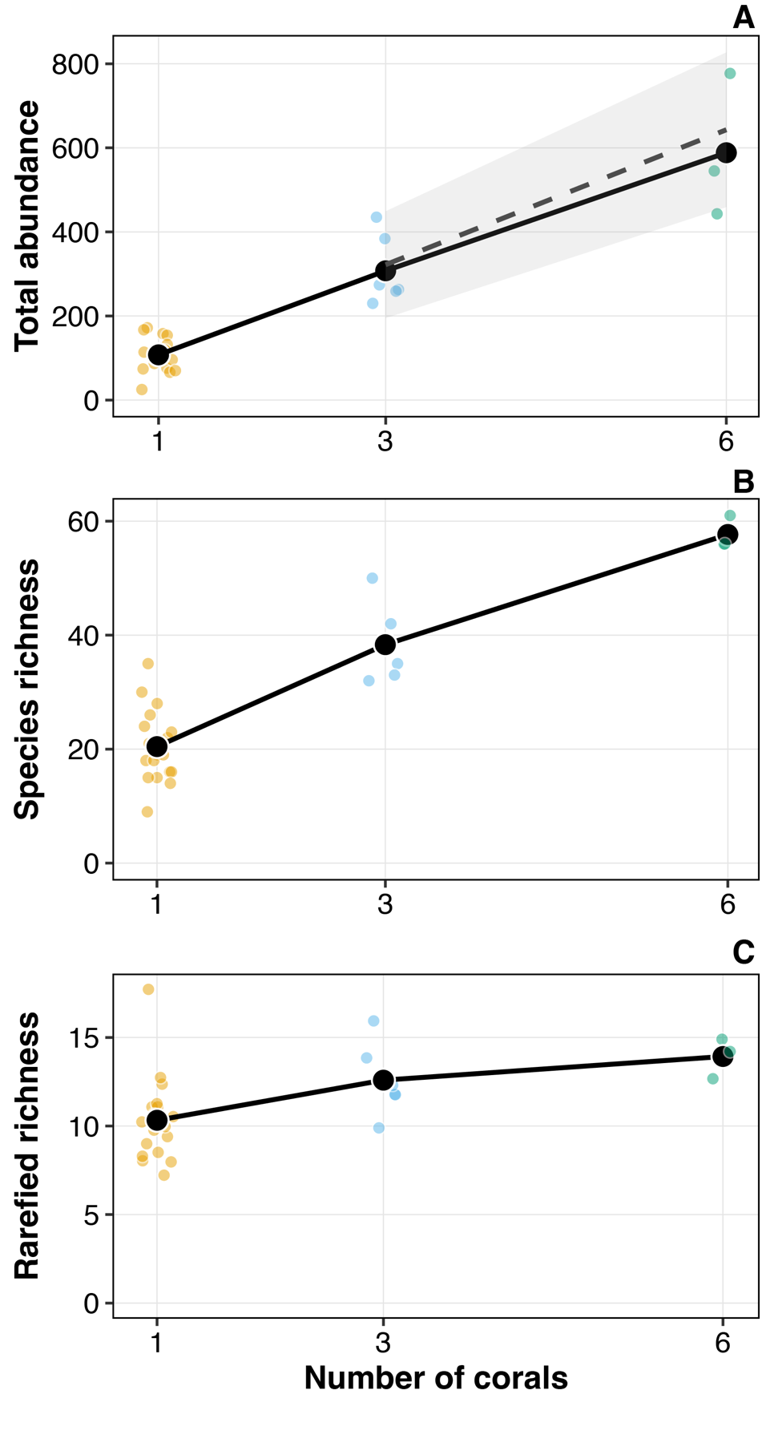
FIGURE 2

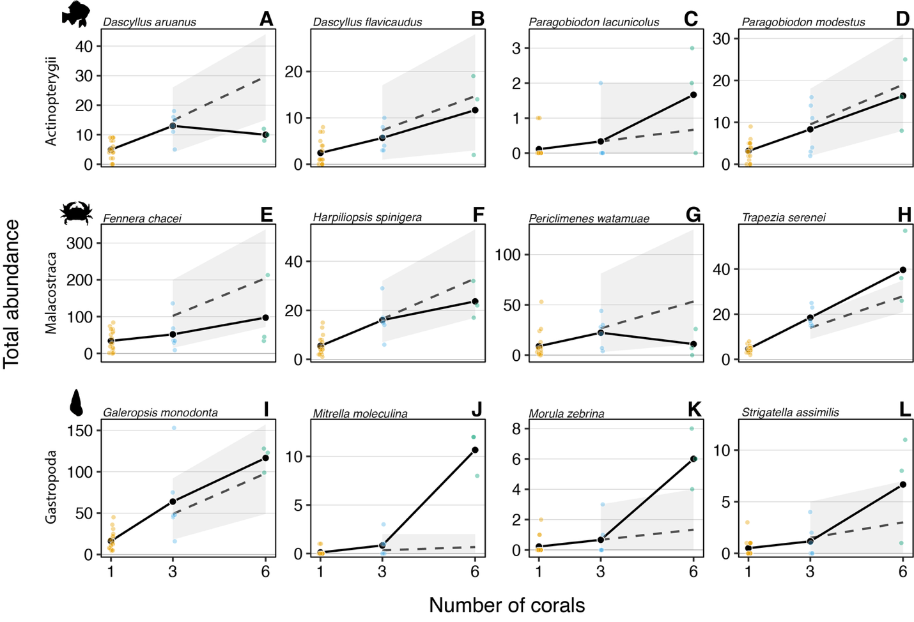
FIGURE 3
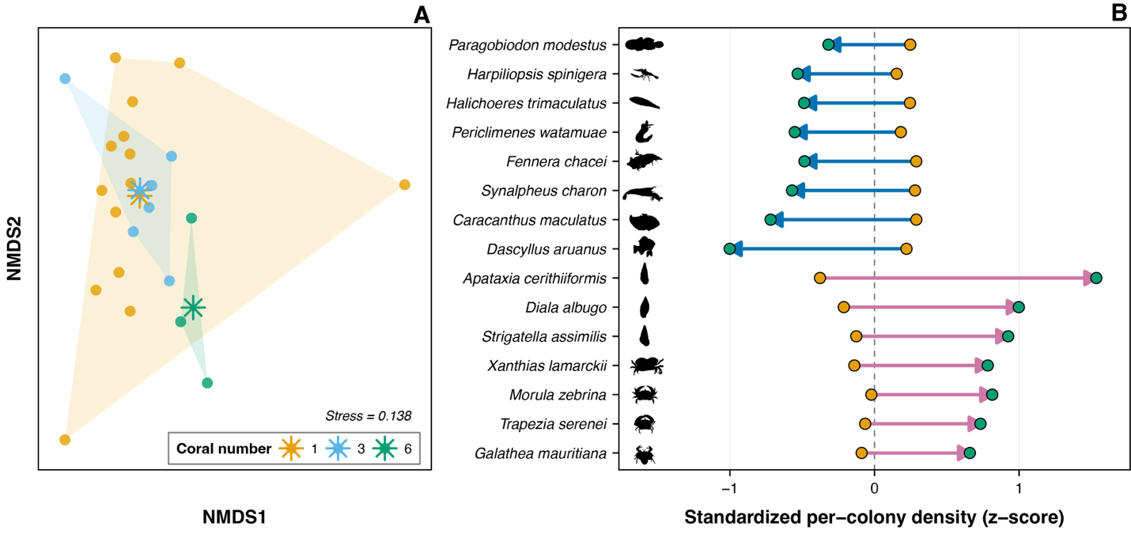
FIGURE 4

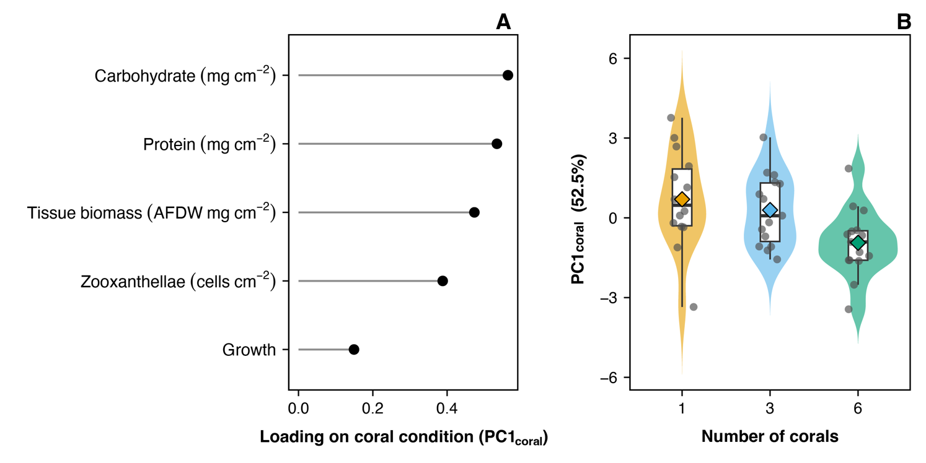

FIGURE 5

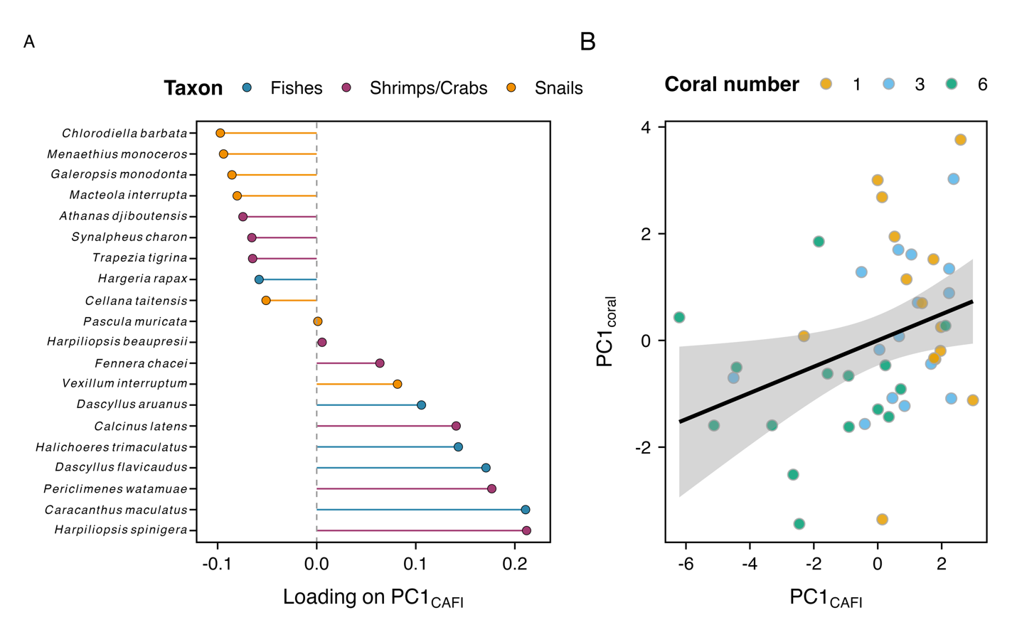
FIGURE 6
